REGIONAL FALL COMPETITION

BIG DATA

AT&T

Bhavana Thangeda

Navya Cheruku

Vishnu Kanth Busetty

**Objective:**

The main objective of this competition is to rate the stores of AT&T in Dallas area based on the content posted in social media by the customers.

**Introduction:**

A huge number of people write their experience and views of AT&T on social media. These comments can be positive, negative, satisfactory, sarcastic etc. These can also be about the services offered, products available at the stores, customer service, quality of service, price of services. The process of analysing this huge of volume data is not an easy task. This process of analysing the data based on the content of social media is called sentiment analysis. The primary purpose of the post or comment can be analysed by a human. The challenge comes when analysing this huge amount of data. The tools used to analyse this may sometimes misinterpret the data and report a totally different picture. There are many tools available in the market for the sentiment analysis. The choice of the tool plays an important role in result.

**Procedure:**

AT&T is a multinational telecommunications conglomerate offering services in different fields of communications. The list services are Cell phones, TV, Bundles, Internet, Accessories, Tablets, Wearables smart devices, Wireless home services, Preowned services. The posts and content on the social media can be regarding one of this service or may be the products they brought from the store. If the content is based on the products that are manufactured by other company and sold through AT&T stores. This needs special attention because the tools analyses the sentiment of the content but doesn’t specify whether it is about the product or the service offered. The main aim of the study is to rate the customer service of AT&T based on the social media content. Selecting the content about the products which are sold at AT&T but not manufactured and maintained will portray a completely different picture. The content should only include the products which are offered by AT&T services and are under their control. The posts regarding the customer service can also be included.

There are so many customer sentiment tools available on the internet. Some of them are paid and some other are having free demo. We have selected a tool which is available for demo. The other tools include crimsonhexagon, meltwater, zoomph,lexalytics,opentext,clarabridge. The data from social media is collected using various customer sentiment tools available in the market. We used one such tool called “Trackur” to pull out data for AT&T from social media. The data from social media such as Facebook, Twitter, custom feeds, Tumblr, Google+, News/Blogs, Reviews, Images/video, Reddit was included. The keywords relating to AT&T can be added in the next search and store that data. The key words such as “#att”,”#uverse”,”#bundlesatt”,”#DirectTV”. The keywords used for the search can be any word related to AT&T a proper study has to be done to select the keywords.

The word AT&T used posts in the United States are searched based on the search criteria as shown below. AT&T is given as keyword and The United States is given Country targeting region and performed save search. The search is saved with the name AT&T.

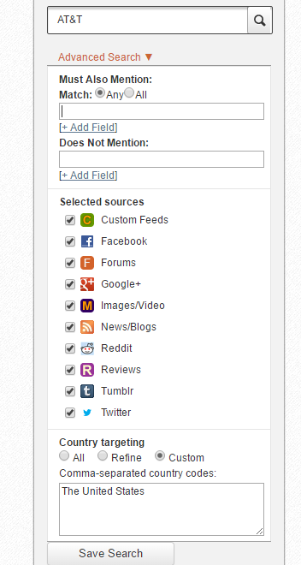

In the saved search section, when AT&T is clicked the posts used in the varied social media are displayed. This can be stored in the excel format by clicking on the excel icon present in the saved search section next to the AT&T.

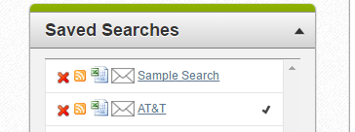

As the excel is clicked the data is exported as CSV and sent to the registered mail ID. The CSV file ‘AT&T -results-10202016.csv’ is added below. The CSV file has sentiment column stating positive, negative and neutral. By this we can filter the reaction of customers for AT&T posts. We have collected a total of 2997 records and out of these 604 are positive ,758 are negative and 1634 are neutral. Further we can segregate the posts location wise by using the keyword or use datamining concept to find out the location of such posts to indicate retail store performance location wise.



References:

1. <https://en.wikipedia.org/wiki/Sentiment_analysis>
2. <https://www.lexalytics.com/technology/sentiment>
3. <http://www.trackur.com>